全文題目(中文或英文) [1]Title (Chinese or English)

Author(s)’ Name(s) (Chinese or mother tongue) / Position / Affiliated Institution

作者姓名 (中文或母語)、所屬機構及職位

Abstract (Chinese or mother tongue)

摘要 (中文或母語)

text

*Keyword* (Chinese character or mother language script)

~ For the following content of paper, please write in either Chinese or English. ~

# heading

text

text[2](footnote number)

text[3](if same reference) *(For format of citation, please refer to the below style page help you.)*

## Heading2

text.

## Heading2

text

### Heading3

#### Heading4

##### Heading5

types of graphic

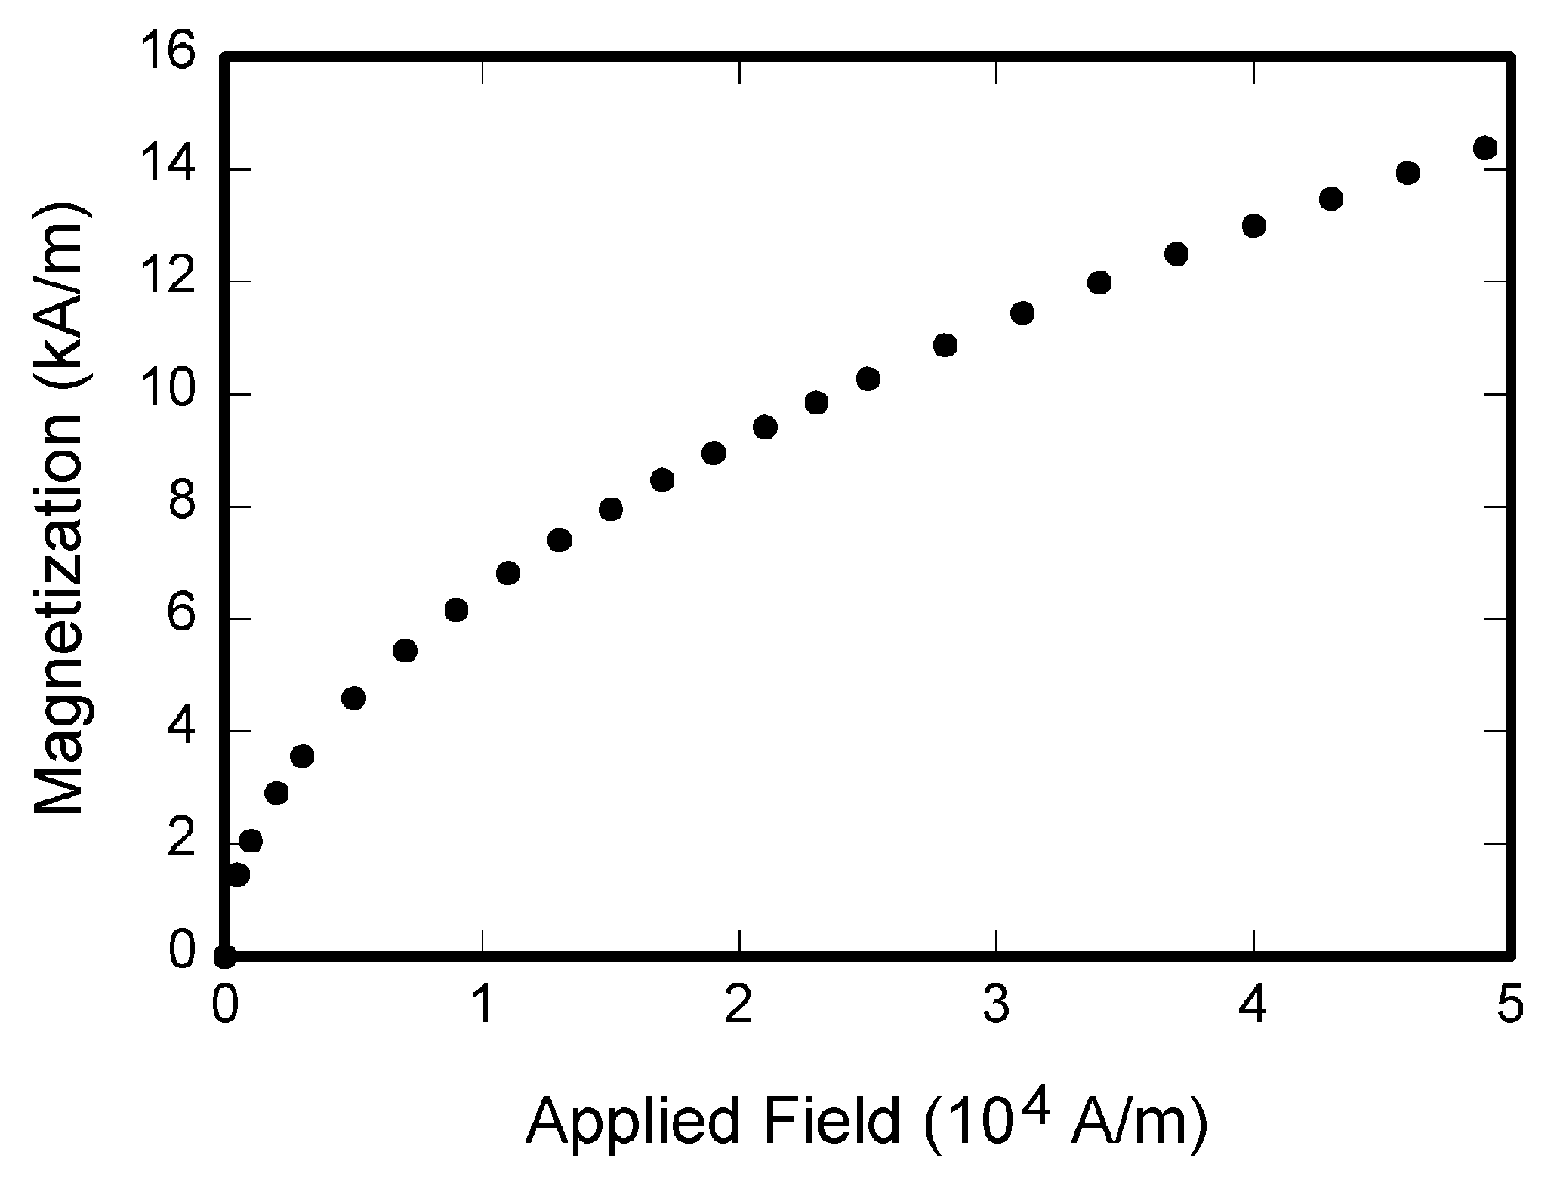

Figure . title

types of table

Table

Title

|  |  |  |
| --- | --- | --- |
| Symbol | Quantity | Conversion from Gaussian and  CGS EMU to SI a |
| Φ | magnetic flux | 1 Mx → 10−8 Wb = 10−8 V·s |
| *B* | magnetic flux density,  magnetic induction | 1 G → 10−4 T = 10−4 Wb/m2 |
| *H* | magnetic field strength | 1 Oe → 103/(4π) A/m |
| *m* | magnetic moment | 1 erg/G = 1 emu  → 10−3 A·m2 = 10−3 J/T |
| *M* | magnetization | 1 erg/(G·cm3) = 1 emu/cm3  → 103 A/m |
| 4π*M* | magnetization | 1 G → 103/(4π) A/m |
| σ | specific magnetization | 1 erg/(G·g) = 1 emu/g → 1 A·m2/kg |
| *j* | magnetic dipole  moment | 1 erg/G = 1 emu  → 4π × 10−10 Wb·m |
| *J* | magnetic polarization | 1 erg/(G·cm3) = 1 emu/cm3  → 4π × 10−4 T |
| χ*,* κ | susceptibility | 1 → 4π |
| χρ | mass susceptibility | 1 cm3/g → 4π × 10−3 m3/kg |
| μ | permeability | 1 → 4π × 10−7 H/m  = 4π × 10−7 Wb/(A·m) |
| μr | relative permeability | μ → μr |
| *w, W* | energy density | 1 erg/cm3 → 10−1 J/m3 |
| *N, D* | demagnetizing factor | 1 → 1/(4π) |

Title (English)

Author(s)’s Name / Position / Affiliated Institution (English)

作者姓名、所屬機構及職位 (英文)

Abstract (must be English)

text

*Keyword* (must be English or Romanization)

References *(samples)*

*Books:*

Abe, Yoshio 阿部善雄, and Hideo Kaneko 金子英生.  Saigo no "Nihonjin" : Asakawa Kan'Ichi no shōgai 最後の「日本人」 : 朝河貫一の生涯 [The last 'Japanese': Life of Kan'ichi Asakawa]. Tōkyō: Iwanami Shoten, 1983.

*Books chapter*

Du, Weisheng 杜伟生. “Dunhuang yishu yongzhi gaikuang ji qianxi” 敦煌遗书用纸概况及浅析 [An analysis and description of the use of paper in Duanhuang manuscripts]. In *Rongshe yu chuangxin: guoji Dunhuang xiangmu diliuci huiyi lunwenji* 融攝与创新: 国际敦煌项目第六次会议论文集 [Tradition and innovation: Proceedings of the 6th International Dunhuang Project conservation conference], edited by Lin Shitian 林世田 and Alastair Morrison, 67-84. Beijing: Beijing tushuguan chubanshe, 2007.

*Journal article:*

Han, T’aesik 韓泰植. “Kyŏnghŭng ŭi saengae e kwanhan chae koch’al”  憬興 의  生涯 에 관한 재고찰 [Re-examination of the life of Kyŏnghŭng]. Pulgyo hakpo 佛敎學報 28 (1991): 187-213.

*Database*

Beijing Airusheng shuzihua jishu yanjiu zhongxin 北京爱如生数字化技术研究中心. Zhongguo jiben guji ku 中国基本古籍库 [Database of Chinese Classic Ancient Books]. Beijing: Beijing Airusheng shuzihua jishu yanjiu zhongxin, 2011. <http://server.wenzibase.com/dblist.jsp>.

*DVD, Films:*

* DVD

Ershisi cheng ji 二十四城记 [24 City]. Directed by Jia Zhangke 贾樟柯.  New York: Cinema Guild, 2010. DVD

Tokyo Story. Directed by Ozu Yasujirō 小津安二郎. 1953. USA: Criterion Collection, 2003. DVD.

* Film

Tōkyō Monogatari 東京物語. Directed by Ozu Yasujirō 小津安二郎. Shōchiku, 1953. Film.

*Newspapers:*

Joo, Yong-jung 주용중, and Chung Woo-sang 정우상. “Miseo gwangubyeong bal-saeng-hamyeon suip jungdan” 美서 광우병 발생하면 수입 중단 [Will Suspend the Import if Mad Cow Disease Attacks in the United States]. *Chosun Ilbo* 朝鮮日報, May 8, 2008.

*Website*

State Council 国务院. “Quanmian zhengque lijie shehuizhuyi xinnongcun jianshe 全面正确理解社会主义新农村建设” [Fully and correctly understand the building of a new socialist countryside]. Last modified March 15, 2006. http://www.gov.cn/node_11140/2006-03/15/content_227640.htm. (accessed August 10, 2011)

Democratic Party of Japan. “DPJ Manifesto for the 2005 House of Representatives Election.” Last modified August 30, 2005. http://www.dpj.or.jp/english/manifesto5/pdf/manifesto_05.pdf. (accessed July 7, 2010)

Romanization Guide for Chinese, Japanese, and Korean Languages

Chinese

The pinyin system has replaced the Wade-Giles system as the standard in the U.S. libraries for creating Latin script readings for Chinese characters. This means, as a general rule, library users must search in pinyin to find Chinese-language materials, regardless of publishing locations. The place names in Taiwan used as subject or as headings for government or geographical entities mostly remain in Wade-Giles, although they are in pinyin when appearing in title, imprint, and other areas of the record. For example, 台中市 as a subject heading is "T'ai-chung shih", but "Taizhong Shi" in the title of a Chinese-language book. In terms of personal names,  those Chinese names in Wade-Giles that have been well established are not converted to pinyin, such as 蒋经国 Chiang Ching-kuo and 李登辉 Lee Teng-hui. We accept all of romanization, like pinyin, wade-giles, and jyutping system.

Korean

Continue to follow the McCune-Reischauer system to romanize Korean with the exceptions noted in this document. See: Romanization of the Korean Language: Based upon its Phonetic Structure by G.M. McCune and E.O. Reischauer, reprinted from the Transactions of the Korea Branch of the Royal Asiatic Society. the [Korean Romanization Converter](http://roman.cs.pusan.ac.kr/input_eng.aspx)may be helpful.

Japanese

The basic Japanese romanization system used in North America is the Modified Hepburn System. Become familiar with the [Romanization Table](https://nihongodera.com/tools/romaji-converter) to convert the pronunciation of scripts into Roman characters. Also, transliteration of Japanese words requires the correct pronunciation (reading) of Japanese words.

Useful link

* Chinese (Putonghua) <https://www.chinesetools.eu/tools/chinese-to-pinyin/>
* Chinese (Taiwan) <https://www.chineseconverter.com/en/convert/wade-giles-to-chinese>
* Chinese(Hongkong) <https://www.chineseconverter.com/cantonesetools/en/cantonese-to-jyutping>
* Korean : http://roman.cs.pusan.ac.kr/input_eng.aspx
* Japanese : https://nihongodera.com/tools/romaji-converter

Style

(You may refer: <http://www.easybib.com/guides/citation-guides/chicago-turabian/>)

Books

Bibliography

Hao, Chunwen 郝春文. Tang houqi wudai Songchu Dunhuang sengni de shehui shenghuo 唐后期五代宋初敦煌僧尼的社会生活 [The social existence of monks and nuns in Dunhuang during the late Tang, Five Dynasties and early Song]. Beijing: Zhongguo shehui kexue chubanshe, 1998.

Abe, Yoshio 阿部善雄, and Hideo Kaneko 金子英生*.  Saigo no "Nihonjin" : Asakawa Kan'Ichi no shōgai* 最後の「日本人」 : 朝河貫一の生涯 [The last 'Japanese': Life of Kan'ichi Asakawa]. Tōkyō: Iwanami Shoten, 1983.

Kang, Ubang 姜友邦. *Wŏnyung kwa chohwa:Han’guk kodae chogaksa ŭi wŏlli*圓融과調和 : 韓國古代彫刻史의原理 [Synthesis and harmony: Principle of the history of ancient Korean sculpture]. Seoul: Yŏrhwadang, 1990.

Footnote

Hao Chunwen 郝春文, Tang houqi wudai Songchu Dunhuang sengni de shehui shenghuo 唐后期五代宋初敦煌僧尼的社会生活 [The social existence of monks and nuns in Dunhuang during the late Tang, Five Dynasties and early Song] (Beijing: Zhongguo shehui kexue chubanshe, 1998), 123.

Abe Yoshio 阿部善雄, and Hideo Kaneko 金子英生, *Saigo no "Nihonjin" : Asakawa Kan'Ichi no shōgai* 最後の「日本人」 : 朝河貫一の生涯 [The last 'Japanese': Life of Kan'ichi Asakawa] ( Tōkyō: Iwanami Shoten, 1983), 55.

Kang Ubang 姜友邦, *Wŏnyung kwa chohwa:Han’guk kodae chogaksa ŭi wŏlli*圓融과調和 : 韓國古代彫刻史의原理 [Synthesis and harmony: Principle of the history of ancient Korean sculpture] (Seoul: Yŏrhwadang, 1990), 190-197.

Book Chapters

Bibliography

Du, Weisheng 杜伟生. “Dunhuang yishu yongzhi gaikuang ji qianxi” 敦煌遗书用纸概况及浅析 [An analysis and description of the use of paper in Duanhuang manuscripts]. In Rongshe yu chuangxin: guoji Dunhuang xiangmu diliuci huiyi lunwenji 融攝与创新: 国际敦煌项目第六次会议论文集 [Tradition and innovation: Proceedings of the 6th International Dunhuang Project conservation conference], edited by Lin Shitian 林世田 and Alastair Morrison, 67-84. Beijing: Beijing tushuguan chubanshe, 2007.

Yoshimi, Shun’ya 吉見俊哉. “Mōhitotsu no media to shite no hakurankai: Genshiryoku Heiwa Riyōhaku no juyō” もう一つのメディアとしての博覧会: 原子力平和利用博の受容 [Expo as another media: reception of Atoms for Peace]. In *Senryō suru me senryō suru koe : CIE/USIS eia to VOA*rajio  占領する眼・占領する声: CIE/USIS映画とVOAラジオ [Occupying Eyes, Occupying Voices: CIE/USIS Films and VOA Radio in Asia during the Cold War], edited by Yoshimi Shun’ya and Tsuchiya Yuka, 291-315. Tōkyō: Tōkyō Daigaku Shuppan, 2012.

Ha, Insu 河仁秀. “Tongsam-dong P’aech’ong chŏnghwa chiyŏk palgul sŏngkwa” 東三洞 貝塚 淨化地域 發掘成果 [Result of the excavation on the shell mounds in Tongsam-dong purification region]. In *Kogohak ŭl tonghae pon Kaya*考古學을통해본加耶 [Kaya seen through archaeology], edited by Han’guk Kogo Hakhoe 한국 고고 학회, 111-133. Seoul: Han’guk Kogo Hakhoe, 2000.

Footnote

Du Weisheng 杜伟生, “Dunhuang yishu yongzhi gaikuang ji qianxi” 敦煌遗书用纸概况及浅析 [An analysis and description of the use of paper in Duanhuang manuscripts], in Rongshe yu chuangxin: guoji Dunhuang xiangmu diliuci huiyi lunwenji 融攝与创新: 国际敦煌项目第六次会议论文集 [Tradition and innovation: Proceedings of the 6th International Dunhuang Project conservation conference], ed. Lin Shitian 林世田 and Alastair Morrison (Beijing: Beijing tushuguan chubanshe, 2007), 74.

Yoshimi Shun’ya 吉見俊哉, “Mōhitotsu no media to shite no hakurankai: Genshiryoku Heiwa Riyōhaku no juyō” もう一つのメディアとしての博覧会: 原子力平和利用博の受容 [Expo as another media: reception of Atoms for Peace], in *Senryō suru me senryō suru koe : CIE/USIS eia to VOA rajio* 占領する眼・占領する声: CIE/USIS映画とVOAラジオ [Occupying Eyes, Occupying Voices: CIE/USIS Films and VOA Radio in Asia during the Cold War], ed. Yoshimi, Shun’ya and Tsuchiya Yuka (Tōkyō: Tōkyō Daigaku Shuppan, 2012). 291-315.

Ha Insu 河仁秀, “Tongsam-dong P’aech’ong chŏnghwa chiyŏk palgul sŏngkwa” 東三洞 貝塚 淨化地域 發掘成果 [Result of the excavation on the shell mounds in Tongsam-dong purification region], in *Kogohak ŭl tonghae pon Kaya*考古學을통해본加耶 [Kaya seen through archaeology], ed. Han’guk Kogo Hakhoe 한국 고고 학회 (Seoul: Han’guk Kogo Hakhoe, 2000), 111-133.

Journal Articles

Bibliography

Hua, Linfu 华林甫. “Qingdai yilai Sanxia diqu shuihan zaihai de chubu yanjiu” 清代以来三峡地区水旱灾害的初步研究 [A preliminary study of floods and droughts in the Three Gorges region since the Qing dynasty]. Zhongguo shehui kexue 中国社会科学 1 (1999): 168–79.

Kondō, Shigekazu 近藤成一.  " Yēru Daigaku Shozō Harima no Kuni Ōbe no Shō Kankei Monjo ni Tsuite" イェール大学所蔵播磨国大部庄関係文書について [On Harima no Kuni Ōbe no Shō Kankei Monjo at Yale University Collection]. Tokyō Daigaku Shiryō Hensanjo Kenkyū Kiyō 東京大学史料編纂所研究紀要 23 (2013) : 1-22.

Han, T’aesik 韓泰植. “Kyŏnghŭng ŭi saengae e kwanhan chae koch’al”  憬興 의  生涯 에 관한 재고찰 [Re-examination of the life of Kyŏnghŭng]. *Pulgyo hakpo*佛敎學報28 (1991): 187-213.

Footnote

Hua Linfu 华林甫, “Qingdai yilai Sanxia diqu shuihan zaihai de chubu yanjiu” 清代以来三峡地区水旱灾害的初步研究 [A preliminary study of floods and droughts in the Three Gorges region since the Qing dynasty], Zhongguo shehui kexue 中国社会科学 1 (1999): 168–79.

Kondō Shigekazu 近藤成一, "Yēru Daigaku Shozō Harima no Kuni Ōbe no Shō Kankei Monjo ni Tsuite" イェール大学所蔵播磨国大部庄関係文書について [On Harima no Kuni Ōbe no Shō Kankei Monjo at Yale University Collection], Tokyō Daigaku Shiryō Hensanjo Kenkyū Kiyō 東京大学史料編纂所研究紀要 23 (2013): 1-22.

Han T’aesik 韓泰植, “Kyŏnghŭng ŭi saengae e kwanhan chae koch’al”  憬興 의  生涯 에 관한 재고찰 [Re-examination of the life of Kyŏnghŭng], Pulgyo hakpo 佛敎學報 28 (1991): 187-213.

Newspaper Articles

Bibliography

Sha, Wutian 沙武田. “Shiku kaogu kaipi Dunghuangxue yanjiu xinlingyu” 石窟考古开辟敦煌学研究新领域 [Cave archeology to open a new field for Dunhuang studies]. Zhongguo shehui kexuebao 中国社会科学报, January 8, 2014.

Joo, Yong-jung 주용중, and Chung Woo-sang 정우상. “Miseo gwangubyeong bal-saeng-hamyeon suip jungdan” 美서 광우병 발생하면 수입 중단 [Will Suspend the Import if Mad Cow Disease Attacks in the United States]. Chosun Ilbo 朝鮮日報, May 8, 2008.

Footnote

Sha Wutian 沙武田, “Shiku kaogu kaipi Dunghuangxue yanjiu xinlingyu” 石窟考古开辟敦煌学研究新领域 [Cave archeology to open a new field for Dunhuang studies], Zhongguo shehui kexuebao 中国社会科学报, January 8, 2014, A05.

Joo Yong-jung 주용중, and Chung Woo-sang 정우상, “Miseo gwangubyeong bal-saeng-hamyeon suip jungdan” 美서 광우병 발생하면 수입 중단 [Will Suspend the Import if Mad Cow Disease Attacks in the United States], Chosun Ilbo 朝鮮日報, May 8, 2008, A1.

Websites / Blogs

Bibliography

State Council 国务院. “Quanmian zhengque lijie shehuizhuyi xinnongcun jianshe 全面正确理解社会主义新农村建设” [Fully and correctly understand the building of a new socialist countryside]. Last modified March 15, 2006. http://www.gov.cn/node_11140/2006-03/15/content_227640.htm. (accessed August 10, 2011)

Democratic Party of Japan. “DPJ Manifesto for the 2005 House of Representatives Election.” Last modified August 30, 2005. http://www.dpj.or.jp/english/manifesto5/pdf/manifesto_05.pdf. (accessed July 7, 2010)

Footnote

“Quanmian zhengque lijie shehuizhuyi xinnongcun jianshe 全面正确理解社会主义新农村建设” [Fully and correctly understand the building of a new socialist countryside], last modified March 15, 2006, http://www.gov.cn/node_11140/2006-03/15/content_227640.htm. (accessed August 10, 2011)

Democratic Party of Japan, “DPJ Manifesto for the 2005 House of Representatives Election,” last modified August 30, 2005, http://www.dpj.or.jp/english/manifesto5/pdf/manifesto_05.pdf, p. 9. (accessed July 7, 2010)

Databases

Beijing Airusheng shuzihua jishu yanjiu zhongxin 北京爱如生数字化技术研究中心. Zhongguo jiben guji ku 中国基本古籍库 [Database of Chinese Classic Ancient Books]. Beijing: Beijing Airusheng shuzihua jishu yanjiu zhongxin, 2011. <http://server.wenzibase.com/dblist.jsp>.

DVDs / Films

Bibliography

* DVD

Ershisi cheng ji 二十四城记 [24 City]. Directed by Jia Zhangke 贾樟柯.  New York: Cinema Guild, 2010. DVD

*Tokyo Story*. Directed by Ozu Yasujirō 小津安二郎. 1953. USA: Criterion Collection, 2003. DVD.

* Film

*Tōkyō Monogatari*東京物語. Directed by Ozu Yasujirō 小津安二郎. Shōchiku, 1953. Film.

Footnote

* DVD

Ershisi cheng ji 二十四城记 [24 City], DVD, directed by Jia Zhangke 贾樟柯 (New York: Cinema Guild, 2010).

Tokyo Story, DVD, directed by Ozu Yasujirō 小津安二郎 (USA: Criterion Collection, 2003).

* Film

Tōkyō Monogatari 東京物語, directed by Ozu Yasujirō 小津安二郎, Shōchiku, 1953, film.

Others

Thesis

**Thesis in print: Unpublished** 

Hosking, Barry C. 2010. "The Control of Gastro-intestinal Nematodes in Sheep with the Amino-acetonitrile Derivative, Monepantel with a Particular Focus on Australia and New Zealand." PhD diss., Ghent University.

**Thesis in print: Published** 

Yen, Hung-Hsun. 2009. Modulation of Immune Responses to DNA Vaccines in Sheep: May a Particular Type of Immune Memory Induced during Vaccination Still be Maintained During Infection? Saarbrücken, Germany: LAP Lambert Academic.

**Thesis from a full text database** 

Beller, Benjamin J. 2014. "Fire History of the Peron Peninsula, Shark Bay, Western Australia Based on Remote Sensing Dendrochronology, and Anecdotal Evidence." M.S. thesis,University of Nebraska at Omaha, ProQuest Dissertations and Theses Global (1564281), http://libproxy.murdoch.edu.au/login?url=https://search-proquest-com.libproxy.murdoch.edu.au/docview/1614190977?accountid=12629.

Conference Paper

Conference Paper in Print Proceedings

Singh, Kamal, and Gary Best. 2004. "Film Induced Tourism: Motivations of Visitors to the Hobbiton Movie Set as Featured in 'The Lord of the Rings'." In *Proceedings of the 1st International Tourism and Media Conference, Melbourne, 2004*, 98-111. Melbourne: Tourism Research Unit, Monash University.

**Conference Paper from the Internet**  
Beckermann, M. 2010. "Regeneration Following Traumatic Brain Injury: Signals, Signposts and Scaffolds." Paper presented at the *Biomedical Sciences and Engineering Conference (BSEC), Oak Ridge National Laboratory, Oak Ridge, TN, May 25-26, 2010*. https://doi.org/10.1109/BSEC.2010.5510841.

**Conference Proceedings**

Hall, Kira, Michael Meacham, and Richard Shapiro, ed. 1989. Proceedings of the Fifteenth Annual Meeting of the Berkeley Linguistics Society: General Session and Parasession on Theoretical Issues in Language Reconstruction, February 18-20, 1989. Berkeley, CA: Berkeley Linguistics Society.

1.
2. Hao Chunwen 郝春文, *Tang houqi wudai Songchu Dunhuang sengni de shehui shenghuo* 唐后期五代宋初敦煌僧尼的社会生活 [The social existence of monks and nuns in Dunhuang during the late Tang, Five Dynasties and early Song] (Beijing: Zhongguo shehui kexue chubanshe, 1998), 123.***(About Romanization, see below “Romanization Guide for Chinese, Japanese, and Korean Languages”***
3. Hao Chunwen 郝春文(1998), 150.